**BST – BASIC TECHNOLOGY JSS3**

SCHEME OF WORK

1. Career prospect and opportunities in technology
2. processing of materials

-wood

3. processing of wood

-conversion

- seasoning

4. processing of wood

- defect in wood

- preservation

5. processing metal

6. processing of ceramics, plastics and rubber

7. drawing practices

- isometric drawing

8. oblique drawing

9. perspective drawing

10. orthographic drawing

11. scale drawing

12. simple blue print reading

week 1; carrier opportunities in technology

We use technology more than ever these days to stay connected to our friends and family, get up-to-date on the latest and greatest happenings in our world and sometimes just to pass the time. With all the computers, tablets, smartphones and other high-tech devices our society is dependent on, we need the skills of professionals in technology jobs to make our obsession with tech possible. The Labor Department predicts that tech jobs will grow faster than the average for all jobs at a rate of 12 percent this decade, but it's not just hiring demand that makes this industry one to watch. U.S. News' Best Technology Jobs of 2017 are also high-paying jobs that boast low unemployment rates. Check out what makes these gigs so great, and read more on [how we rank the best jobs](https://money.usnews.com/money/careers/articles/how-us-news-ranks-the-best-jobs).

* [Computer Systems Analyst](https://money.usnews.com/careers/best-jobs/computer-systems-analyst)

 #1 in Best Technology Jobs

Computer systems analysts must have a diverse skill set. The position requires information technology and business knowledge. These analysts custom design computer systems and processes for clients. From 2014 to 2024, the BLS predicts 118,600 job openings in the field.

[Software Developer](https://money.usnews.com/careers/best-jobs/software-developer)

 #2 in Best Technology Jobs

Software developers need to be innovative, creative and, of course, technical in order to succeed in this field. They might write new code or fix bugs in code to make it work better. The BLS predicts 19 percent employment growth with more than 135,000 new jobs opening up by 2024.

[IT Manager](https://money.usnews.com/careers/best-jobs/it-manager)

 #3 in Best Technology Jobs

Our increasingly digital workplace demands more IT managers, who coordinate computer-related activities for an organization. Duties include analyzing and recommending computer needs, installing and maintaining computer hardware and software, securing an office’s network and electronic documents and searching for new technologies and upgrade opportunities. The BLS expects employment to grow 15 percent from 2014 to 2024.

[Web Developer](https://money.usnews.com/careers/best-jobs/web-developer)

 #4 in Best Technology Jobs

Web developers create everything you see on your favorite websites, from the special effects to the search functionality. This is also one of the fastest-growing jobs for 2016, and it oftentimes requires only an associate degree if you have the desire to code. The Labor Department predicts a 27 percent employment growth by 2024.

[Computer Network Architect](https://money.usnews.com/careers/best-jobs/computer-network-architect)

 #5 in Best Technology Jobs

If you've ever saved something to the cloud, then you've depended on the handiwork of a computer network architect. These professionals design, build and maintain a variety of data communication networks, from expansive cloud infrastructures to smaller intranets. According to the BLS, the computer network architecture profession is growing at a rate of 9 percent from 2014 to 2024, which should result in 12,700 new jobs.[more](https://money.usnews.com/careers/best-jobs/computer-network-architect)

[Database Administrator](https://money.usnews.com/careers/best-jobs/database-administrator)

 #6 in Best Technology Jobs

While the pronunciation of the word “data” always seems to be up for debate, the importance of protecting said data is not. Database administrators set up databases according to a company’s requirements, in addition to maintaining its operations and implementing the appropriate security measures. According to the BLS, 13,400 new database administrator positions will open.

[Information Security Analyst](https://money.usnews.com/careers/best-jobs/information-security-analyst)

 #7 in Best Technology Jobs

As concern about cybersecurity grows, so does the demand for information security analysts. The BLS predicts employment to grow 18 percent between 2014 and 2024. It is the duty of these professionals to prepare and carry out security measures that protect a company’s computer networks and systems.[more](https://money.usnews.com/careers/best-jobs/information-security-analyst)

[Computer Support Specialist](https://money.usnews.com/careers/best-jobs/computer-support-specialist)

 #8 in Best Technology Jobs

A computer support specialist’s job is a combination of customer service and troubleshooting. These specialists help computer owners and users troubleshoot and fix problems. The BLS projects 88,800 new jobs will open in the field from 2014 to 2024.[more](https://money.usnews.com/careers/best-jobs/computer-support-specialist)

[Computer Systems Administrator](https://money.usnews.com/careers/best-jobs/network-and-computer-systems-administrator)

 #9 in Best Technology Jobs

Computer systems administrators perform duties ranging from identifying and fixing network issues to updating equipment and software. These administrators are in demand. From 2014 to 2024, the BLS projects that 30,200 jobs will be added to the field.[more](https://money.usnews.com/careers/best-jobs/network-and-computer-systems-administrator)

[Computer Programmer](https://money.usnews.com/careers/best-jobs/computer-programmer)

 #10 in Best Technology Jobs

Computer programmers write the code that makes software programs run. In addition to writing and converting code and maintaining and testing software and programs, a huge part of this job involves problem solving. Programmers address issues that arise when converting programs into code and debug when necessary. According to the BLS, employment in the field is expected to decline 8 percent from 2014 to 2024 because companies may hire computer programmers from other countries with lower wages.[more](https://money.usnews.com/careers/best-jobs/computer-programmer)

question;

1. define career
2. list 5 related profession in technology

week 2; processing of materials

[wood];

**Wood processing** is an [engineering](https://en.wikipedia.org/wiki/Engineering) discipline comprising the production of forest products, such as pulp and [paper](https://en.wikipedia.org/wiki/Paper), construction materials, and [tall oil](https://en.wikipedia.org/wiki/Tall_oil). [Paper engineering](https://en.wikipedia.org/wiki/Paper_engineering) is a subfield of wood processing. The major wood product categories are: sawn timber, wood-based panels, wood chips, paper and paper products and miscellaneous others including poles and railway sleepers. Forest product processing technologies have undergone extraordinary advances in some of the above categories. Improvements have been achieved in recovery rates, durability and protection, greater utilization of NTFPs such as various grain stalks and bamboo, and the development of new products such as reconstituted wood-panels. Progress has not been homogenous in all the forest product utilization categories. Although there is little information available on the subjects of technology acquisition, adaptation and innovation for the forest-based industrial sector, it is clear that sawmilling has been far less affected by the spread of innovations than the manufacturing of panel products.[[1]](https://en.wikipedia.org/wiki/Wood_processing#cite_note-1)

Wood processing produces additives for further processing of timber, wood chips, cellulose and other prefabricated material.

# 6 steps to successful tree felling

*When felling trees, the correct working techniques are essential for not only creating a safe working environment, but also working more effectively.*

### 1. Plan ahead

When it comes to tree removal using a chainsaw, preparation is key. If you plan the felling and which forestry equipment to bring, not only are you in for a safer working session, but your post-felling work will also be a lot easier. First, ask yourself if there are any major obstacles – such as overhead lines, roads or buildings – in the area. Deploy warning signs if you know that a road crosses the work area or that a lot of people pass by on a daily basis.

### 2. Check the felling direction

Continue by carefully studying the tree to determining the felling direction. How do the branches look and how do they grow? Also, take the wind direction into consideration. If you’re unsure of the tree’s natural direction of fall, step away from the tree and check with a plumb line (see fact box for details). Clear around the tree in the intended felling direction. Also clear about 45 degrees behind the tree in both directions, creating your path of retreat.

### 3. Prune the trunk

Once you have cleared the area, put up your warning signs and decided on the tree’s direction of fall and your path of retreat, check that you have enough fuel in the tank for the task ahead. Then it’s time to prune the trunk to get rid of all the branches and twigs that might get in the way when sawing the felling cut. The safest way to prune is to work with a pulling chain (underside of the [chainsaw guide bar](http://www.husqvarna.com/us/accessories/chainsaw-bars/)) from the top down.

### 4. Decide on cutting technique

Once the trunk is twig-free up to shoulder height, it’s time to make the felling cut. When doing this, it’s important to remember two things: the hinge should have a uniform thickness with the right dimensions, and the [felling wedge](http://www.husqvarna.com/us/accessories/wedges/) or breaking bar should be inserted before the tree can pinch the guide bar. Which technique you should use for making the cut depends on the tree size and slope, and on the size of your chainsaw. We have put together information about the different techniques here, so that you can determine which method best suits your conditions.

### 5. Check for diseases

If you notice that the timber is discolored and soft, or if the lower part of the trunk looks swollen or diseased, you need to be very careful. This is an indication that the tree is infested with rot and that the wood fibers are weakened. When this happens, fell in the tree’s natural direction of fall and use a winch if you are unsure. Rot infestation usually subsides higher up in the tree so one option might be to fell the tree with an extra high stump.

### 6. Choose your tool

There are several felling tools to choose from when taking down a tree. The size of the tree determines which type of forestry equipment you need. For smaller trees, you do not normally need felling tools. Hand force is enough, possibly with the help of a long pole. A felling wedge provides greater felling force than the different types of breaking bars. In extreme cases, you can use a rope and a winch, which is the safest and most powerful way to fell a tree. Have a look at the fact box for more information about the different tools.

question;

1. explain processing of wood
2. list 5 part of a tree

week 3; processing wood

### wood conversion; QUICK ANSWER

**Wood conversion is the process where a newly felled tree is converted into workable lumber.** There are many different cuts that can be used to convert a downed tree to lumber.

[**CONTINUE READING**](https://www.reference.com/business-finance/wood-conversion-ff4d495791780839)

## KEEP LEARNING

## [What is wood laminating?](https://www.reference.com/hobbies-games/wood-laminating-34c4ee981b68d094)

## [How is wood made from trees?](https://www.reference.com/business-finance/wood-made-trees-587b6b1f940e498b)

## [What is the process of tree logging?](https://www.reference.com/business-finance/process-tree-logging-9e663a838291452b)

### FULL ANSWER

If the lumber is going to be used for construction, the wood is cut plain or through and through. This is less expensive to cut, and while it does produce increased chances of cupping, the wood is stronger when used properly. If the lumber is intended for decorative purposes, it is cut quartered or rift sawn. This is more expensive and produces more waste; however, the wood is much more decorative in appearance and is less prone to both cupping and expansion.

## [Conversion and processing](https://content.cat.org.uk/index.php/woodland-management/15-about-our-woodland--woodland-management-woodland/about-our-woodland--woodland-management/100-conversion-and-processing)

**Conversion**

The conversion of timber is a phrase usually used in reference to turning a log into a pile of boards/planks. This is done using a saw mill of some kind. There are several things that need to be taken into account when sawing up a log. It is important to take into account the taper (the difference in size between the two ends of the log). The size of the taper affects how a log needs to be cut up in order for the best use to be made of its timber. The size of the planks or boards that are needed, any heart rot or shakes (cracks) in the log and how round the log is, are also factors that affect how it should be sawn up to get the best use out of it.

When converting timber using a saw mill, having a handy local saw mill can be very useful. However, depending on the quantity of timber that needs to be sawn up, and the distance to the saw mill, it may be better both environmentally and financially to hire, or even buy, a mobile sawmill.

**Processing**

Before wood can be converted or seasoned, it must be processed. After felling the tree, the branches need to be removed from the main stem leaving a clean trunk. This is then cross cut to the appropriate lengths required depending on whether it is providing wood for planking, stakes for fencing, firewood etc. The branch wood can also be useful for many purposes such as charcoal, rustic furniture and hedge stakes, so may need to be sorted.

**Seasoning**

Once wood has been processed and/or converted, seasoning must take place. Seasoning is the term used to describe drying wood. Seasoning wood is important because otherwise it will shrink during usage and be more susceptible to rot. In the case of firewood, the less moisture it contains, the better it will burn and the less smoke it will produce.

When seasoning wood, in whatever form, air circulation is vital. If air circulation is insufficient, moisture will be trapped between the wood stopping it from drying properly and causing bacterial or fungal decay. Unless it is dried using a kiln, wood takes around two years to dry out properly.

Firewood is simpler to season than sawn wood as there is no need to worry about the wood splitting or becoming stained. So long as it is stacked under shelter with sufficient gaps for air flow it will dry out well. Two methods of seasoning firewood are as follows. Cut logs to size (4ft lengths are traditional), cleave the logs in to quarters or smaller depending on their diameter and stack the lengths for a year. Then saw them into useable lengths and stack them for a further year until they are ready to use.

Alternatively leave them to dry in the round for a year then saw them into stumps and split them using an axe or maul. However you chose to split them, when stacking firewood the layers should be stacked alternately i.e. if the first layer is stacked facing forward the second should be stacked facing sideways.

Stacking sawn planks or boards is different however. They do not want to be touching or they will not dry properly and will probably end up stained. To allow air circulation, small bits of wood often called sticks or stickers are place between the planks as they are stacked. There is no set size for these sticks though they are usually around 1x1 inch. The smallness of the sticks minimises contact and reduces the likelihood of stain however to further reduce the risk it is important that the sticks are free from dirt or decay.

Another issue with seasoning sawn planks or boards is their tendency to warp or develop shakes (splits). To avoid this it is important that the sticks are placed evenly throughout the stack, both horizontally and vertically otherwise the pressures placed on the timber will be unbalanced and this causes warping. Also the planks or boards should be stacked out of direct sunlight as its heat accelerates the drying process. If the timber is dried too fast, then the inside will not be able to dry as fast as the outside and so the outside shrinks faster which is what causes shakes.

question;

1. what is wood conversion
2. define wood seasoning

week 4; processing of wood

# defects in wood; WOOD DEFECTS

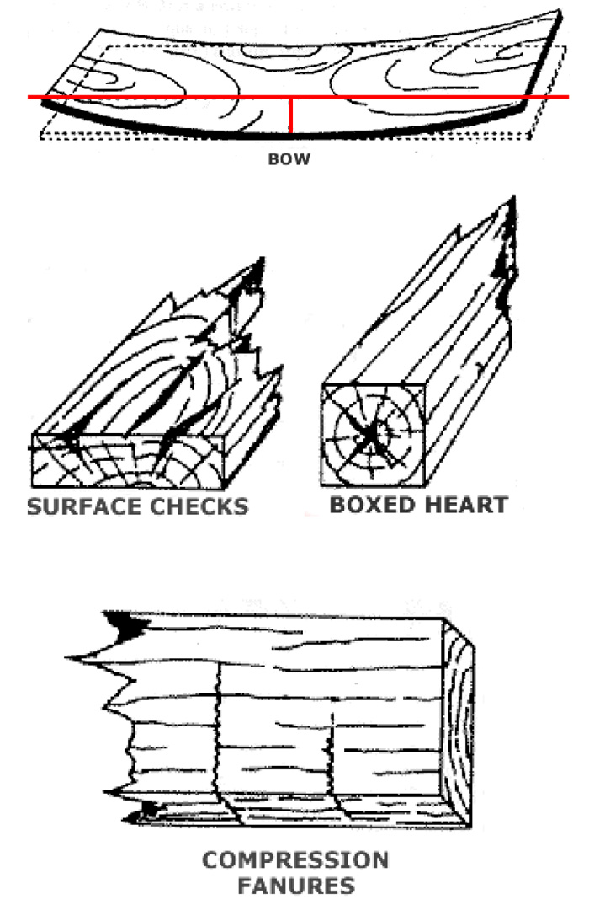

Timber is far from being a stable and consistent material. One of the biggest challenges of working with timber is learning to work within the constraints of a timber’s. The following are a list of the most common wood defects.

## BOW (BOWING)

The curvature of a piece of sawn timber in the direction of its length, cf. Spring and Curvature.

## BOXED HEART

A term used when the heart is enclosed within the four surfaces of a piece of sawn timber. Well boxed Heart means that the heart is enclosed within the four surfaces of piece of sawn or hewn timber throughout its entire length, and is reasonably well centered at both ends.

## CHECKS

Are small separations of the wood fibers in a longitudinal Wood Defects direction, not penetrating as far as the opposite or adjoining side of a piece of sawn timber; they usually result from strains developing during seasoning; Surface (or Seasoning) Checks, and End (or Heart) Checks are distinguished.

## COMPRESSION FANURES

Are fractures across the grain in which the fibers are broken transversely or are crushed by compression. Various causes are suggested, such as felling across obstructions, and failure inside the growing tree caused by high winds, growth stresses, etc. ls also known as Felling Shakes, Thunder, Rupture, Lightning, and Transverse Shakes, Upsets, Cross Breaks, or Cross Fractures. Very often they are difficult to detect until the timber is dressed.

## http://www.davidstimber.com.au/wp-content/uploads/2013/08/wood-defects-2.jpg

## CUP (CUPPING)

The curvature of a piece of sawn timber across its width.

## DIAMOND (DIAMONDING)

A distortion due to differential shrinkage in drying that causes a piece of timber originally square (or rectangular) in cross section to become diamondshaped. This defect occurs when the rays pass through diagonal corners of the square (or rectangle) and is caused by  the difference between tangential and radial shrinkage which in many timbers is in the proportion of about 2:1.

## HONEYCOMB

(Internal Checks) The development of checks in the interior of a piece of wood due to drying stresses, usually along the wood rays, often not visible at the surface. This defect  occurs when thick timber is dried too quickly in a seasoning-kiln.

## SPLIT (ALSO KNOWN AS A SHAKE)

Is a longitudinal separation of the fibers which extends to the opposite face or adjoining edge of a piece of sawn timber.

## SPRING

Is the curvature of a piece of sawn timber in the plane of its wide face: known as Crook or Free Side Bend.

## http://www.davidstimber.com.au/wp-content/uploads/2013/08/wood-defects-3.jpg

## TWISTING

Is the spiral distortion of a piece of sawn timber; it may be accompanied by either bowing or spring, or both.

## WANE (WANT)

Is the lack of wood on any face or edge of a piece of sawn timber, usually caused by a portion of the original rounded surface of a long remaining on the piece; bark may or may not be present.

Defects that exist in timber make the planer’s job more difficult and create a need for secondary machinery to produce quality products. It would be nice to be able to feed any piece of rough timber into a moulder and produce a perfect product, free from defects, but this seldom happens.

The numerous processes required to work timber free of defects are well known to the furniture, moulding, flooring and architectural woodwork industries. Most companies split their manufacturing operations into a rough mill and a finish mill. The job of the rough mill is to break down the timber to more uniform sizes and pre-work the main defects from the wood. The following section details the different types of planning processes and discusses the operations in the rough mill.

## SLOPE OF GRAIN

Localised slope of grain can be caused by knots. Slope of grain can also be caused by a slight bend in the tree, which means that when a straight board is cut out of it, there is a bend in the grain. This tends to be a longer feature and may go unnoticed in an appearance product.

Some species of Australian hardwoods (such as Jarrah and Blackbutt) can have “wavy grain”. This gives a very attractive rippled appearance in high surface finish applications.

Where timber is “backsawn”, the slope of grain can give interesting effects in the growth rings that enhance the appearance of the timber for some applications.

wood preservation; Many commonly used wood species can deteriorate if exposed to conditions that support growth of wood-degrading organisms. Wood products can be protected from the attack of decay fungi, harmful insects, or marine borers by applying chemical preservatives. Preservative treatments greatly increase the life of wood structures, thus reducing replacement costs and allowing more efficient use of forest resources. The degree of protection achieved depends on the preservative used and the proper penetration and retention of the chemicals. Some preservatives are more effective than others, and some are more adaptable to certain use requirements. To obtain long-term effectiveness, adequate penetration and retention are needed for each wood species, chemical preservative, and treatment method. Not only are different methods of treating wood available, but treatability varies among wood species—particularly their heartwood, which generally resists preservative treatment more than does sapwood. Although some tree species possess naturally occurring resistance to decay and insects (see Chap. 14), many are in short supply or are not grown in ready proximity to markets. In considering preservative treatment processes and wood species, the combination must provide the required protection for the conditions of exposure and life of the structure. All these factors are considered by the consensus technical committees in setting reference levels required by the American Wood Protection Association (AWPA, formerly American Wood-Preservers’ Association)) and ASTM International (formerly American Society for Testing and Materials). Details are discussed later in this chapter. The characteristics, appropriate uses, and availability of preservative formulations may have changed after preparation of this chapter. For the most current information on preservative formulations, the reader is encouraged to contact the appropriate regulatory agencies, standardization organizations, or trade associations. Note that mention of a chemical in this chapter does not constitute a recommendation.

question;

1. describe wood preservation
2. list 3 methods of applying preservatives

week 5; processing metal

|  |  |
| --- | --- |
| **Metal processing** | |
| [*What is a Metal ?*](https://depts.washington.edu/matseed/mse_resources/Webpage/Metals/metals.htm)    [*Structures of Metals*](https://depts.washington.edu/matseed/mse_resources/Webpage/Metals/metalstructure.htm)    [*Metal Properties*](https://depts.washington.edu/matseed/mse_resources/Webpage/Metals/metalproperty.htm) |  | In industry, molten metal is cooled to form the solid. The solid metal is then mechanically shaped to form a particular product. How these steps are carried out is very important because heat and plastic deformation can strongly affect the mechanical properties of a metal.    Grain Size Effect:    It has long been known that the properties of some metals could be changed by [heat treating](http://matse1.mse.uiuc.edu/~tw/metals/glos.html#ht). Grains in metals tend to grow larger as the metal is heated. A grain can grow larger by atoms migrating from another grain that may eventually disappear. Dislocations cannot cross grain boundaries easily, so the size of grains determines how easily the dislocations can move. As expected, metals with small grains are stronger but they are less ductile. Figure 5 shows an example of the grain structure of metals.    Quenching and Hardening:    There are many ways in which metals can be heat treated. [Annealing](http://matse1.mse.uiuc.edu/~tw/metals/glos.html#ann) is a softening process in which metals are heated and then allowed to cool slowly. Most steels may be hardened by heating and [quenching](http://matse1.mse.uiuc.edu/~tw/metals/glos.html#qu) (cooling rapidly). This process was used quite early in the history of processing steel. In fact, it was believed that biological fluids made the best quenching liquids and urine was sometimes used. In some ancient civilizations, the red hot sword blades were sometimes plunged into the bodies of hapless prisoners! Today metals are quenched in water or oil. Actually, quenching in salt water solutions is faster, so the ancients were not entirely wrong.    Quenching results in a metal that is very hard but also brittle. Gently heating a hardened metal and allowing it to cool slowly will produce a metal that is still hard but also less brittle. This process is known as tempering. (See Processing Metals Activity). It results in many small Fe3C precipitates in the steel, which block dislocation motion which thereby provide the strengthening.    Cold Working:    Because plastic deformation results from the movement of dislocations, metals can be strengthened by preventing this motion. When a metal is bent or shaped, dislocations are generated and move. As the number of dislocations in the crystal increases, they will get tangled or [pinned](http://matse1.mse.uiuc.edu/~tw/metals/glos.html#pin) and will not be able to move. This will strengthen the metal, making it harder to deform. This process is known as [cold working](http://matse1.mse.uiuc.edu/~tw/metals/glos.html#cw). At higher temperatures the dislocations can rearrange, so little strengthening occurs.    You can try this with a paper clip. Unbend the paper clip and bend one of the straight sections back and forth several times. Imagine what is occurring on the atomic level. Notice that it is more difficult to bend the metal at the same place. Dislocations have formed and become tangled, increasing the strength. The paper clip will eventually break at the bend. Cold working obviously only works to a certain extent! Too much deformation results in a tangle of dislocations that are unable to move, so the metal breaks instead.    Heating removes the effects of cold-working. When cold worked metals are heated, recrystallization occurs. New grains form and grow to consume the cold worked portion. The new grains have fewer dislocations and the original properties are restored. |
|  |

\

metal alloy

An [alloy](https://www.thoughtco.com/alloy-definition-examples-and-uses-606371) is a material made by melting one or more metals together with other elements. This is an alphabetical list of alloys grouped according to the base metal of the alloy. Some alloys are listed under more than one element, since the composition of the alloy may vary such that one element is present in a higher concentration than the others.

### ALUMINUM ALLOYS

* AA-8000: used for building wire
* Al-Li (aluminum, lithium, sometimes mercury)
* Alnico (aluminum, nickel, copper)
* Duralumin (copper, aluminum)
* Magnalium (aluminum, 5% magnesium)
* Magnox (magnesium oxide, aluminum)
* Nambe (aluminum plus seven other unspecified metals)
* Silumin (aluminum, silicon)
* Zamak (zinc, aluminum, magnesium, copper)
* Aluminum forms [other complex alloys](https://www.thoughtco.com/aluminum-or-aluminium-alloys-603707) with magnesium, manganese, and platinum

properties of metals

|  |  |
| --- | --- |
| **Metals:** | Non-metals: |
| Strong | Brittle |
| Malleable and ductile | Brittle |
| React with oxygen to form basic oxides | React with oxygen to form acidic oxides |
| Sonorous | Dull sound when hit with hammer |
| High melting and boiling points | Low melting and boiling points |
| Good conductors of electricity | Poor conductors of electricity |
| Good conductors of heat | Poor conductors of heat |
| Mainly solids at room temp. Exception mercury - liquid at room temp. | Solids, liquids and gases at room.temp. |
| Shiny when polished | Dull looking |
| When they form ions, the ions are positive | When they form ions, the ions are negative - except hydrogen that forms a positive ion, H+. |
| High density | Low density |

**Common Metals and Non-Metals**

|  |  |
| --- | --- |
| **Metals:** | **Non-metals:** |
| Calcium | Sulphur |
| Potassium | Oxygen |
| Lead | Chlorine |
| Copper | Hydrogen |
| Aluminium | Bromine |
| Zinc | Nitrogen |
| Lithium | Helium |

#### Uses of metals and non-metals

***Metals***

**The uses of metals are related to their properties:**

They are made into jewellery due to their hard and shiny appearance.

They are used to make pans, since they are good conductors of heat.

They are used in electrical cables, because they are malleable, ductile and good conductors of electricity.

They are strong so used to build scaffolding and bridges.

They make a ringing sound, sonorous, hence their use in bell making.

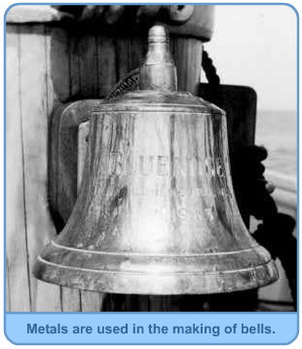

***Non-metals***

Used as insulating material around wire cables since they do not conduct electricity.

Used to make pan handles as they are poor conductors of heat.

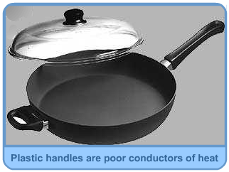

### question;

### describe 5 properties of metals

### state 5 uses of metals

### week 6; processing of ceramics and glass

# Ceramic Material Manufacturing Methods

All ceramics start as a mixture of powdered base material (Zirconia, etc.), binders and stabilizers. This mixture is "formed" into shapes and then fired (sintered) at high temperature to create hard, dense materials. Forming is done using standard processes such as pressing, extruding, injection molding, tape casting or slip casting. Ceramics can also be machined prior to being fired using standard machine tools in a process known as "green machining." Green machining is inexpensive because unfired material is soft. However, firing causes ceramics to lose 20% to 40% of their volume; therefore, green machining followed by firing is suitable only for those applications with loose tolerances (~1% of characteristic lengths). In contrast, tight tolerance parts must be machined using high speed, diamond tools after ceramics are fired.

Some of the better known ceramic manufacturing processes combine sintering with forming.

### ****Sintering (Firing)****

Ceramics are consolidated into dense material by exposing them to 1800°C - 2000°C for days or weeks at a time, depending on the ceramic and process details. The addition of the thermal energy promotes strong bonds between the raw ceramic particles, leading to densification. Green machined, near net shapes or raw stock material can be sintered. Knowledgeable ceramics manufacturers are very adept at accounting for volumetric shrinkage.

### ****Hot Pressing****

Hot pressing combines the forming and firing steps to produce relatively simple geometric shapes. The ceramic powder is simultaneously subjected to sintering temperatures and uniaxial pressure. Simple shapes are generated by placing the raw material in a high temperature die while under load.

### ****Hot Isostatic Pressing (HIP)****

Hot isostatic pressing is a uniform pressure assisted method of sintering ceramics into simple and complex shapes. The pressure, usually applied via an inert gas like Argon to prevent reactions, significantly reduces porosity and therefore improves physical properties. Often times, the pressurization process is preceded by evacuating all air to reduce moisture and impurities. In order for the hot isostatic press process to work, the green ceramic must be placed in a gas tight container. An alternative method is to pre-sinter the ceramic to remove porosity at the surfaces. In this way, the ceramic material itself acts as the pressure vessel. Hot isostatic pressing differs from isostatic pressing in that the former applies uniform pressure to the ceramic during sintering.

### ****Chemical Vapor Deposition (CVD)****

Chemical vapor deposition is the process of converting gases (called precursors) into solids by continuously depositing monolayers of material onto a heated substrate. This is a thermodynamically driven process, so control of substrate temperature and chamber pressure is critical. Certain ceramic materials, such as Silicon Carbide and Silicon Nitride, can be manufactured using chemical vapor deposition techniques. Shapes are formed using sacrificial targets premachined into the desired shape of the part. Although the resulting material is much more expensive than its conventionally made counterparts, the cost is warranted by applications requiring superior physical properties.

### ****Reaction Bonding****

Reaction bonding uses a chemical reaction to bind ceramic powders into a solid form. After forming, the binder is burned off to create a porous preform, and then capillary pressure is used to infiltrate liquefied reactants (different reactants for different ceramics) into the preform at temperatures just above the ceramic melting point. The resulting reaction creates the solid ceramic form. For example, liquefied Si is used in reaction bonded Silicon Carbide. The main disadvantage of reaction bonded ceramics is that it leads to relatively high porosity.

plastic and rubber

# Methods of Processing Plastic

There are a variety of methods used to process plastic. Each method has its advantages and disadvantages and are better suited for specific applications. These methods include: injection molding, blow molding, thermoforming, transfer molding, reaction injection molding, compression molding, and extrusion.

**Injection Molding**

The main method used for processing plastic is [injection molding](http://www.plasticsindustry.com/injection-molding.asp). With this process, the plastic is placed into a hopper. The hopper then feeds the plastic into a heated injection unit, where it is pushed through a long chamber with a reciprocating screw. Here, it is softened to a fluid state.

A nozzle is located at the end of the chamber. The fluid plastic is forced through the nozzle into a cold, closed mold. The halves of the mold are held shut with a system of clamps. When the plastic is cooled and solidified, the halves open and the finished product is ejected from the press.

Thermosetting materials usually are not processed with injection molding because they will soften, they harden to an infusible state. If they are processed with injection molding, they need to be moved through the heating chamber quickly so they do not set.

**Blow Molding**

Blow molding is used when the plastic item to be created needs to be hollow. A molten tube is created with blow molding by using compressed air, which blows up the tube and forces it to conform to the chilled mold. Variations of blow molding include injection, injection-stretch, and extrusion blow molding.

With injection blow molding uses a perform, which is taken to a blow mold and filled with compressed air. As a result, it conforms to the interior design of the blow mold. With injection-stretch blow molding, a the plastic is stretched prior to being formed. Otherwise, it is essentially the same as the injection process.

With continuous-extrusion, a molten plastic tube is continuously created. At the appropriate times, the tube is pinched between two mold halves. Then, a needle or a blow pin is inserted into the tube and blows compressed air up the part in order to force it to conform to the mold interior. With accumulator-extrusion, the molten plastic material is gathered in the chamber before it is forced through a die in order to form a tube.

**Thermoforming**

Thermoforming uses a plastic sheet, which is formed with the mold by applying air or through mechanical assistance. The air pressure used can be nearly zero psi, or several hundred psi. At 14 psi, which is equivalent to atmospheric pressure, the pressure is created by evacuating the space between the mold and the sheet. This is known as vacuum forming.

**Transfer Molding**

Transfer molding is generally used only for forming thermosetting plastics. It is similar to compression molding because the plastic is cured into an infusible state through pressure and heat. Unlike compression molding, however, transfer molding involves heating the plastic to a point of plasticity prior to being placed into the mold. The mold is then forced closed with a hydraulically operated plunger.

Transfer molding was initially developed as a method for molding intricate products, such as those with many metal inserts or with small, deep holes. This is because compression molding sometimes disturbed the position of the metal inserts and the holes of these types of products. With transfer molding, on the other hand, the liquefied plastic easily flows around the metal parts without causing them to change position.

**Reaction Injection Molding**

Reaction injection molding, or RIM, is one of the newer processes used in the plastics industry. It differs from liquid casting in that the liquid components are mixed together in a chamber at a lower temperature of only about 75 to 140 degrees Fahrenheit before it is injected into a closed mold. Here, an exothermic reaction occurs. As a result, RIM requires less energy than other injection molding systems. Reinforced RIM, or R-RIM, involves adding materials such as milled or chopped glass fiber in the mixture in order to increase the stiffness.

**Compression Molding**

Compression molding is the most common process used with thermosetting materials and is usually not used for thermoplastics. With this process, the material is squeezed into its desired shape with the help of pressure and heat. Plastic molding powder and other materials are added to the mix in order to create special qualities or to strengthen the final product. When the mold is closed and heated, the material goes through a chemical change that causes it to harden into its desired shape. The amount temperature, amount of pressure, and length of time utilized during the process depends on the desired outcome.

**Extrusion**

The process of extrusion is usually used to make products such as film, continuous sheeting, tubes, profile shapes, rods, coat wire, filaments, cords, and cables. As with injection molding, dry plastic material is placed into a hopper and fed into a long heating chamber. At the end of the chamber, however, the material is forced out of a small opening or a die in the shape of the desired finished product. As the plastic exits the die, it is placed on a conveyor belt where it is allowed to cool. Blowers are sometimes used to aid in this process, or the product may be immersed in water to help it cool.

|  |
| --- |
|  |
|  |
| Topics Covered |
| [List Topics](https://www.azom.com/article.aspx?ArticleID=3580#_Background)  [Natural Rubber Trees](https://www.azom.com/article.aspx?ArticleID=3580#_Natural_Rubber_Trees)  [Dry Rubber Production](https://www.azom.com/article.aspx?ArticleID=3580#_Dry_Rubber_Production)  [Tapping Rubber Trees](https://www.azom.com/article.aspx?ArticleID=3580#_Tapping_Rubber_Trees)  [Processing of Natural Rubber](https://www.azom.com/article.aspx?ArticleID=3580#_Processing_of_Natural)  [Natural Rubber Production](https://www.azom.com/article.aspx?ArticleID=3580#_Natural_Rubber_Production)  [Applications of Natural Rubber](https://www.azom.com/article.aspx?ArticleID=3580#_Applications_of_Natural) |
| Background |
| Thailand, Malaysia and Indonesia are the largest producers of natural rubber in the world. Figures from the World Trade organisation posted on www.thailand.com indicate the following worldwide natural rubber production in 1998.   |  |  | | --- | --- | | Country | Production (Tons) | | Thailand | 2,065,000 | | Indonesia | 1,680,000 | | Malaysia | 866,000 | | India | 591,000 | | China | 450,000 | | Africa | 334,000 | | Vietnam | 219,000 | | Latin America | 112,000 | | Sri Lanka | 96,000 | | Philippines | 64,000 | | Others | 113,000 | | **Total** | **6,590,000** |   Natural rubber comes from the Havea brasiliensis tree, which grows in tropical regions. They typically reach 20-30 metres in height on rubber plantations, and are able to produce commercial quantities of latex at about 7 years of age, depending on climate and location. Economical life span of a rubber tree is between 10 to 20 years, but may extend past 25 years in the hands of a skilled tapper and bark consumption.  It should be noted that latex is different to tree sap. Dry Rubber ProductionTapping Rubber Trees Havea trees are not tapped any more often than once per day, with 2 or 3 days being the norm. In countries such as Thailand, tapping usually takes place in the early hours of the morning, prior to dawn due to the high day time temperatures and the protective clothing worn to protect against snakes etc. Also flow rates are increased due to higher turgor pressures at these times.  A tapper uses a sharp hook shaped knife to shave a thin layer of fresh bark from the tree. This exposes the latex vesicles. The cut is typically done at 25-30° to the horizontal, as this exposes the maximum number of vesicles. The same incision is re-opened the next time (typically the next day) by shaving off a small amount of bark. Virgin bark is exposed first working around in panels. The same area may be exploited again after about 7 years.  AZoM - Metals, ceramics, polymers and composites - Tapping a rubber tree using angular, semi-spiral incisions.  **Figure 1.** Tapping a rubber tree using angular, semi-spiral incisions.  The thickness of the layer is important as too thick a slice will damage the tree and reduce its productivity and life, while too thin a slice will not produce sufficient latex. Bark is removed in a localised area for a period of time, and then a new area is tapped allowing the tree to repair itself.  The latex runs down and is collected in a cup. Each tree usually produces about half a cup of latex per day and is collected later in the day. Latex will flow for approximately 1 to 3 hours after which time the vesicles become plugged with coagulum. Processing of Natural Rubber Processing of natural rubber involves the addition of a dilute acid such as formic acid. The coagulated rubber is then rolled to remove excess water.  AZoM - Metals, ceramics, polymers and composites - Rolling the latex into thin sheets.  **Figure 2.** Rolling the latex into thin sheets.  Then a final rolling is performed using a textured roller and the resultant rubber sheet is dried. Following this, the rubber is ready for export of further processing. This type of natural rubber accounts for about 90% of natural rubber production.  AZoM - Metals, ceramics, polymers and composites - Final rolling of the latex sheets using a textured roller.  **Figure 3.** Final rolling of the latex sheets using a textured roller.  AZoM - Metals, ceramics, polymers and composites - The dried sheet of latex.  **Figure 4.** The dried sheet of latex. Natural Rubber Production Natural rubber is used in a pure form in some applications. In this case, the latex tapped from trees is concentrated using centriguges, removing water and proteinaceous materials. It is then preserved using a chemical such as ammonia. |
| Applications of Natural Rubber |
| The natural rubber is used for making products such as:  •         Glue  •         Tyres  •         Toys  •         Shoes  •         Condoms  •         Gloves  •         Catheters  •         Balloons  •         Some medical tubing  •         Elastic thread |

question;

1. explain methods of processing ceramics
2. explain processing of natural rubber

week 7; drawing practices

 isometric drawing; A pictorial representation of an object in which all three dimensions are drawn at full scale rather than foreshortening them to the true projection. An isometric drawing looks like an isometric projection but all its lines parallel to the three major axes are measurable.  
  
**Isometric drawing,**also called **isometric projection**, method of graphic representation of three-dimensional objects, used by engineers, technical illustrators, and, occasionally, architects. The technique is intended to combine the [illusion](https://www.merriam-webster.com/dictionary/illusion) of depth, as in a [perspective](https://www.britannica.com/art/perspective-art) rendering, with the undistorted presentation of the object’s principal dimensions—that is, those parallel to a chosen set of three mutually perpendicular coordinate axes.

* 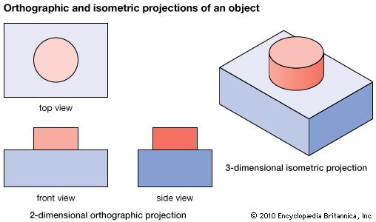

Encyclopædia Britannica, Inc.

The isometric is one class of orthographic projections. (In making an [orthographic projection](https://www.britannica.com/topic/orthographic-projection-engineering), any point in the object is mapped onto the [drawing](https://www.britannica.com/art/drawing-art) by dropping a perpendicular from that point to the plane of the drawing.) An isometric [projection](https://www.britannica.com/science/projection-cartography) results if the plane is oriented so that it makes equal angles (hence “isometric,” or “equal measure”) with the three principal planes of the object. Thus, in an isometric drawing of a cube, the three visible faces appear as equilateral parallelograms; that is, while all of the parallel edges of the cube are projected as parallel lines, the horizontal edges are drawn at an angle (usually 30°) from the normal horizontal axes, and the vertical edges, which are parallel to the principal axes, appear in their true proportions.

question

1. define isometric
2. draw isometric block

week 8; oblique drawing

## Definition of oblique drawing

1. **:**  a projective drawing of which the frontal lines are given in true proportions and relations and all others at suitable angles other than 90 degrees without regard to the rules of linear perspe

[pp3df4401b.gif](http://www.design-technology.info/booklist/default.htm)

[pp3df4401b.gif](http://www.design-technology.info/page31.htm)

[pp3df4401b.gif](http://www.design-technology.info/KS3/Y7/default.htm)

[pp3df4401b.gif](http://www.design-technology.info/KS3/Y8/default.htm)

[pp3df4401b.gif](http://www.design-technology.info/KS3/Y9/default.htm)

1. [pp3df4401b.gif](http://www.design-technology.info/engineers)
2. [pp3df4401b.gif](http://www.design-technology.info/home.htm)
3. [pp3df4401b.gif](http://www.design-technology.info/IndProd/page10.htm)
4. [pp3df4401b.gif](http://www.design-technology.info/IndProd/page12.htm)
5. **‘Cabinet Oblique’**  
   **In *Cabinet oblique* the scale (depth) is halved whilst in Cavalier**  
   **oblique the depth scale is the same as in the X and Y directions.**
6. **One remaining drawing conventions is Oblique drawing –**  
     
   **In this convention the angles used are 45 degrees and 90 degrees.  The only difference between the two named styles is in the scale of the dimension going away from the viewer.**  
   **This first example is *Cavalier Oblique* and shows the full scale (1:1) in the axis**
7. **This drawing (shown to the left) is symmetric about the horizontal centre-line.**  
     
   **Centre-lines are chain-dotted and are used for symmetric objects, and also for  showing the centre of circles and holes.**  
   **Drawing dimensions should generally be done directly to the centre-line, as shown on the left.   In many cases this method**  
   **can be clearer than just dimensioning**  
   **between surfaces.**  
     
   **Note again that the measurements show only numbers.  The statement at the bottom of the drawing identifies that these numbers are the dimensions in *Millimetres*.**
8. 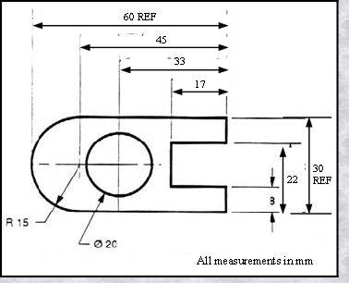
9. 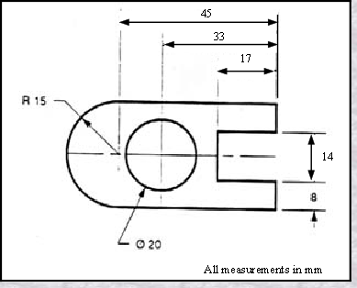
10. 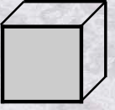
11. 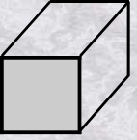
12. **A Simple Guide to Dimensions ... Continued ...**  
      
    **With the left side of the block composed solely of  "radiuses" (radii)  - as shown here, we break our rule that we should not duplicate dimensions. The total length is known because the radius of the curve on the left side is given.  Then, for clarity, we add the overall length of  60 and we note that it is a reference (REF)  dimension.**  
    ***This means that it is not really required.***  
      
    **Somewhere on the paper, usually the bottom, there should be placed information on what measuring system is being used    (e.g. inches and millimetres) and also the scale of the drawing.**

question;

* 1. define oblique drawing
  2. draw oblique block

week 9; perspective drawing

*…a mathematical system for representing three-dimensional objects and space on a two-dimensional surface by means of intersecting lines that are drawn vertically and horizontally and that radiate from one point on a horizon line…*

Although this definition sounds complicated, the concept is relatively simple. One point perspective is a drawing method that shows how things appear to get smaller as they get further away, converging towards a single ‘vanishing point’ on the horizon line. It is a way of drawing objects upon a flat piece of paper (or other drawing surface) so that they look three-dimensional and realistic.

Drawing in one point perspective is usually appropriate when the subject is viewed ‘front-on’ (such as when looking directly at the face of a cube or the wall of building) or when looking directly down something long, like a road or railway track. It is popular drawing method with architects and illustrators, especially when drawing room interiors. To understand more about the history of perspective in art, please read our accompanying Guide to Linear Perspective (coming soon).

Note: If you need to draw something that is not facing you directly, but rather has a corner nearest to you, two point perspective is likely to be more appropriate.

### Rules of perspective: true shapes, vanishing points and horizon lines

In one point perspective, surfaces that face the viewer appear as their **true shape**, without any distortion. They are drawn using primarily horizontal and vertical lines, as illustrated by the diagram below:

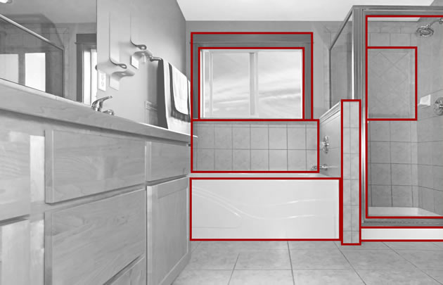In this one point perspective photo, surfaces facing the viewer are undistorted and show their true shape. For example, we see the side of the bath, window and facing surfaces as ordinary squares and rectangles. Their sides are parallel with the edges of the photograph.

Surfaces that travel away from the viewer, on the other hand, converge towards a single ‘**vanishing point**‘. This is a point that is located directly in front of the viewer’s eyes, on a ‘**horizon line**’ (also known as an ‘eye level line’), as illustrated in the photo below:

All receding edges of the buildings in this one point perspective photo angle towards the single vanishing point. The position of the vanishing point tells us that the photographer was crouching down, with his eye level lowered.

It is possible to draw over photographs to identify vanishing points, horizon lines and true shapes. Studying the work of famous artists can also help you gain an understanding of one point perspective, as shown in the example by Vincent van Gogh below.

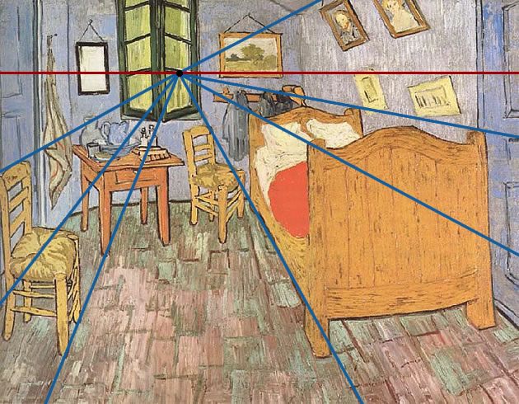‘Bedroom in arles’ by Vincent van Gogh – identifying perspective lines

**Key Points:**

* Surfaces that face the viewer are drawn using their true shape
* Surfaces that travel away from the viewer converge towards a single vanishing point

## One point perspective tutorial

The following tutorial explains how to draw one point perspective step-by-step. The exercises are designed to be completed in the order given, with each one building upon the previous task. All worksheets are available as a free [**perspective drawing PDF**](http://www.studentartguide.com/wp-content/uploads/2015/02/perspective-drawing.pdf) that can be printed at A4 size (more worksheets will be added to this over time).

The [downloadable PDF](http://www.studentartguide.com/wp-content/uploads/2015/02/perspective-drawing.pdf) has been provided by the Student Art Guide for classroom use and may be issued freely to students (credited to studentguide.com), as well as shared via the social media buttons at the bottom of this page. The worksheets may not be published online or shared or distributed in any other way, as per our [terms and conditions](http://www.studentartguide.com/terms-and-conditions).

**Recommended Equipment:**

* Mechanical or ‘clutch’ pencil (with an HB or 2H lead)
* Blank paper and/or the printed worksheets

A ruler and compass can be useful while learning to draw in one point perspective, however most Art students find that these exercises are best completed freehand, with dimensions and proportions gauged by eye. This is so that the skills are easily transferrable to an observational drawing.

question

1. explain 1 point perspective drawing
2. draw an object in 1point perspective

week 10; orthographic drawing

te and imagine you are shopping for a chair to go in your living room. You find the perfect one, but it is way too expensive. Fortunately, you have a cousin that builds furniture. Maybe he can build the chair for you! Describing the chair over the phone was more than a challenge. Your cousin suggests you send him pictures of the chair from multiple angles, along with the measurements.

This experience illustrates the process that a furniture designer must go through in order for the manufacturer to create the chair as intended. Three-dimensional drawings can be used to show the overall concept and design, but they are often not clear or detailed enough. Orthographic drawings can help to overcome those challenges.

An **orthographic drawing** represents a three-dimensional object using several two-dimensional views of the object. It is also known as an orthographic projection. For example, you can see in this image the front, top and side views of an aircraft.

|  |
| --- |
| 3 views of plane |

## Two Different Styles

There are two different styles of orthographic projections:

|  |
| --- |
| First-angle projection |
| ***First-Angle Projection*** |

In **first-angle projection**, each view is shown as if the viewer is looking through the object and projecting the image on the other side. This style is the most common one used in Europe. Here is example of first-angle projection (see video). The red arrows represent the view of the observer with the image being projected on the other side.

|  |
| --- |
| Third-angle projection |
| ***Third-Angle Projection*** |

In **third-angle projection**, each view is created as if the object is projecting an image away from itself onto a plane in front of it. It is the image exactly as the observer sees it on that side. Third-angle projection is the preferred style in the United States.

The results of the two styles are very similar. The main difference is the position of the images. It's all about the **perspective**. Just like first-person and third-person describes perspective in literature, first-angle and third-angle describe the perspective of the projection. Not knowing which style was used may result in a product with a similar image but incorrect orientation.

question

1. differentiate between 1st angle projection and 3rd angle projection
2. draw object in orthographic form